**QR CODE:**

Quick Response Code is a popular type of a two-dimensional barcode. It encodes alphanumeric information. To decode this, you can either use a handheld scanner or even a QR Code scanning application on your smartphone.

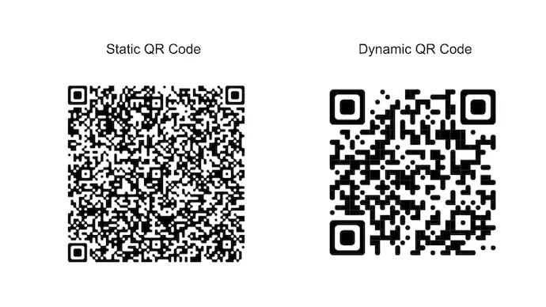

**STATIC QR CODE:**

A static QR Code has the target URL directly encoded and will never expire. So, when you scan a static QR Code, you will be redirected to the target URL with no additional intermediate links in between. This ensures that the QR Code will live forever and continues to work as long the target URL is online.

**Content that we can store in a Static QR Code:**

A Static QR Code can store the following content:

* URL: Leads the user to a web page
* Text: Display simple text such as message, promo code, or serial code
* Contact Details: Displays contact information and allows users to save you as a contact
* Wifi Credentials: Android devices can access Wifi network. iOS devices can view network name and password
* Maps location: Shows location on Google Maps
* Calendar Event: Prompts user to save an event (with details) to their phone calendar
* Phone number: Prompts user to dial the number
* Email Address: Open mail application with your email in the recipient field

**APPLICATIONS OF STATIC QR CODE:**

1. For Management and Engagement

You can use QR Codes in the following use cases:

* Inventory Management

We can create Static QR Code to manage our inventory efficiently. We can create and paste the QR Code on every product.

* Product Packaging

We can create a Static QR Code to provide detailed information about our product. For example, if we have a food and beverage company, we can use Static QR Code to provide information about GMO ingredients.

* Product Catalogue

We can use Static QR Code in our product catalogue to provide more information or interesting facts. This way we can engage our customers better.

* Event Management

We can use Static QR Code in bulk to manage your events better. For example, if its a large scale event, we can put the QR Code on various spots containing the event schedule.

2. For Business and Marketing

* For our business Card

We can create Static QR Code and encode our contact details. Upon scanning, the end users will directly be able to save our contact in their phonebook. That is, all the manual work in saving a contact will be eliminated.

* For our employee identity card

We can create Static QR Codes in bulk for our employees. Similar to QR Code based business card, we can store contact details (such as name, employee code, designation).

Upon scanning via a smartphone, the details of the respective employee will appear. This will ensure authentic entries in our workspace.

* Present additional work

Similarly, we can also use static QR Codes to manage projects or to showcase our unique work such as mobile apps, project documents, designs, or articles

If we are a creative professional such as a graphic designer,we can link our artworks to QR Codes

**DYNAMIC QR CODE:**

A Dynamic QR Code never stores the target data directly. It stores a short URL that redirects the end-users to the target data.

Hence, a dynamic QR Code can be edited anytime we want. No need to create a new QR Code each time we want to change the encoded content.

**APPLICATIONS OF DYNAMIC QR CODE:**

* Event QR Code:

To organize an event, whether formal or informal, we hand out printed invitation cards. They help our guests know details such as date and time of the event, and venue location.

An Event QR Code here helps us simplify many things.

For example—it helps guests add the event to their calendars in a simple click, RSVP easily, and see the exact venue location on Google Maps

* Social Media QR Code

It creates a landing page with links to all your social media profiles. Users can then select their favorite site and follow you.

* App Store QR Code

Say you’re an app developer and you’ve created a new app. You want to get people to download it. And you’re using print media to promote it.

But here’s the thing. To install your app people will have to type the link or its name, find it, and finally install it.

This is a long process and needs effort. And to be honest, many people will simply not put the required effort.

When scanned, it identifies the operating system of the scanning device and redirects it to the right app store.